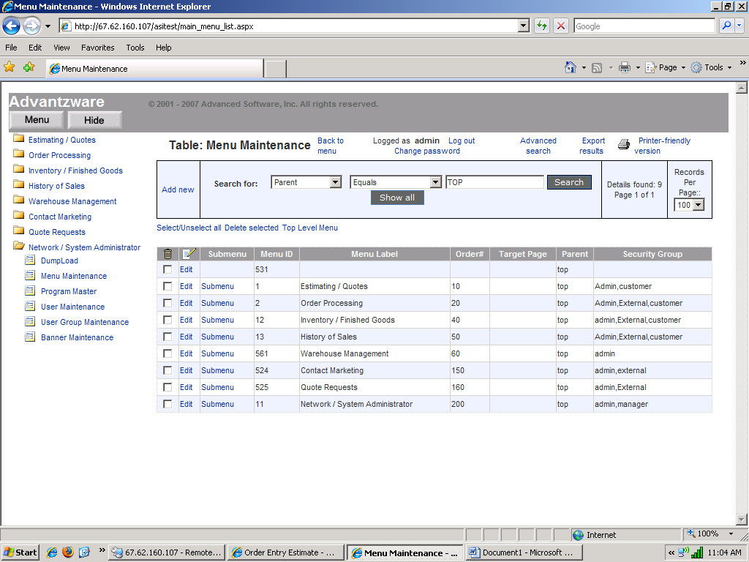

Through this screen we can add Menu Items
click on Add new.

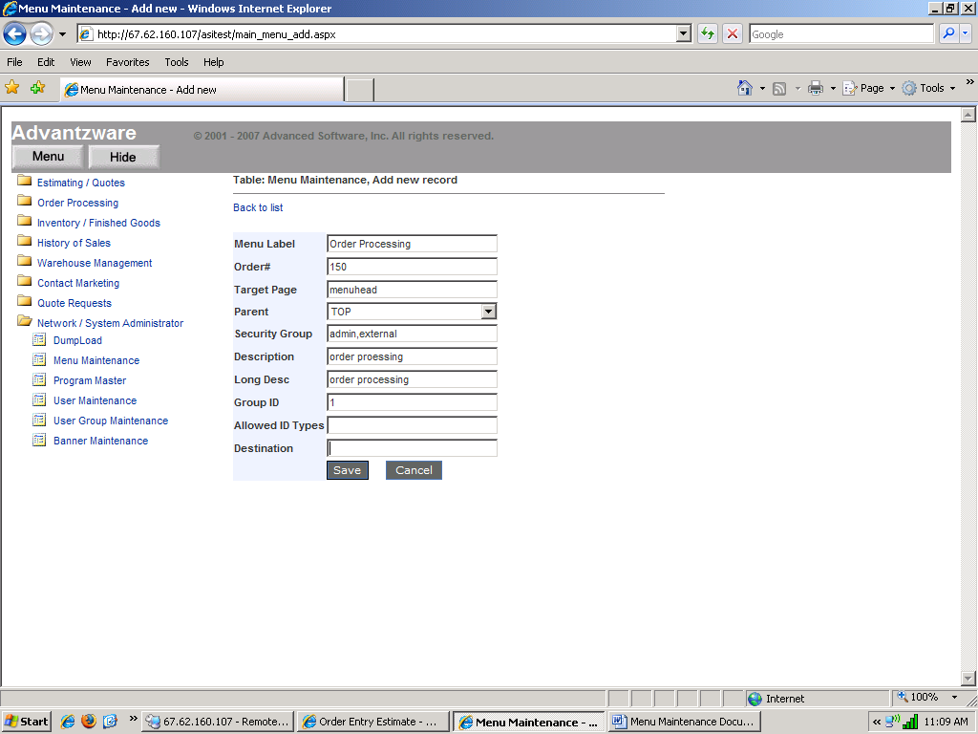

On click of Add new :- From here we can add new menu item.

Menu Lable : Name of the Label we want to show on menu.
Order# : To set the position of the menu label.
Target Page: When we give target page “menuhead” it create the folder which will contain further subfolders for submenus.
Parent: To set the parent menu of submenu.
Security Group: To set the permission for users to use that menu.
Description: To give the Discription of menu lable.
Group Id: Should be always 1.
Destination: when Target Page is menuhead then destination should be blank.

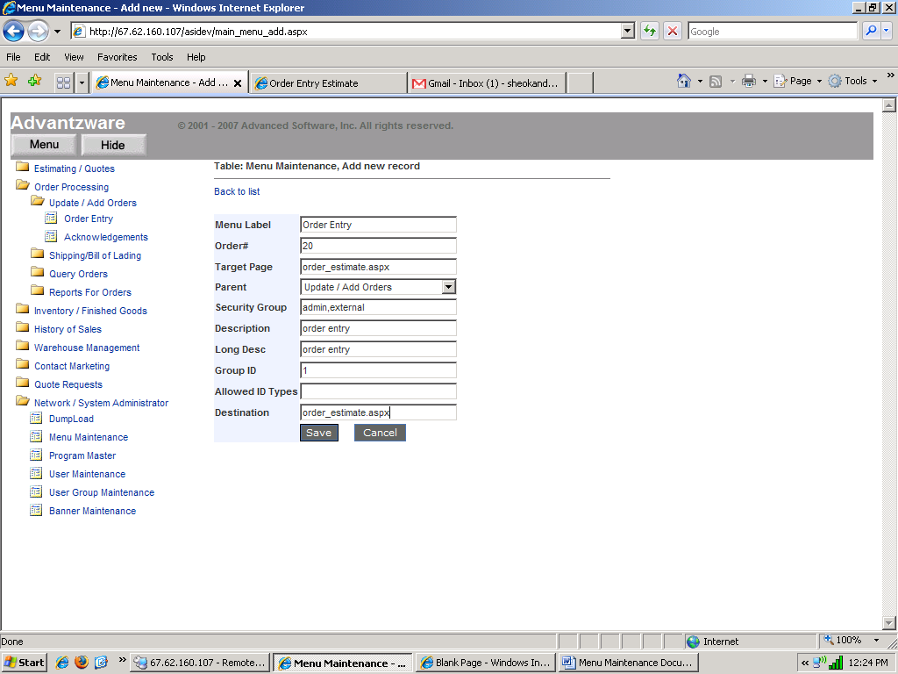

When we add a menu item has a target page.
Target Page : aspx file name which will call on select of that menu item
eg. Order_Estimate.aspx.
Destination: Same file name as we give on target page eg. Order_Estimate.aspx.

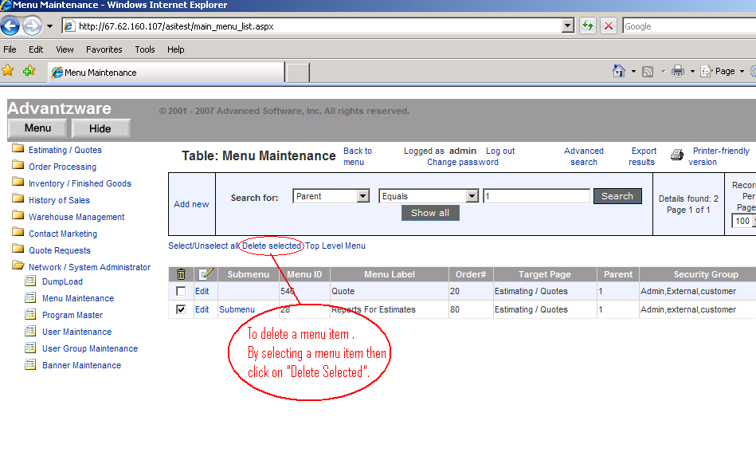

To Delete a Menu Item.

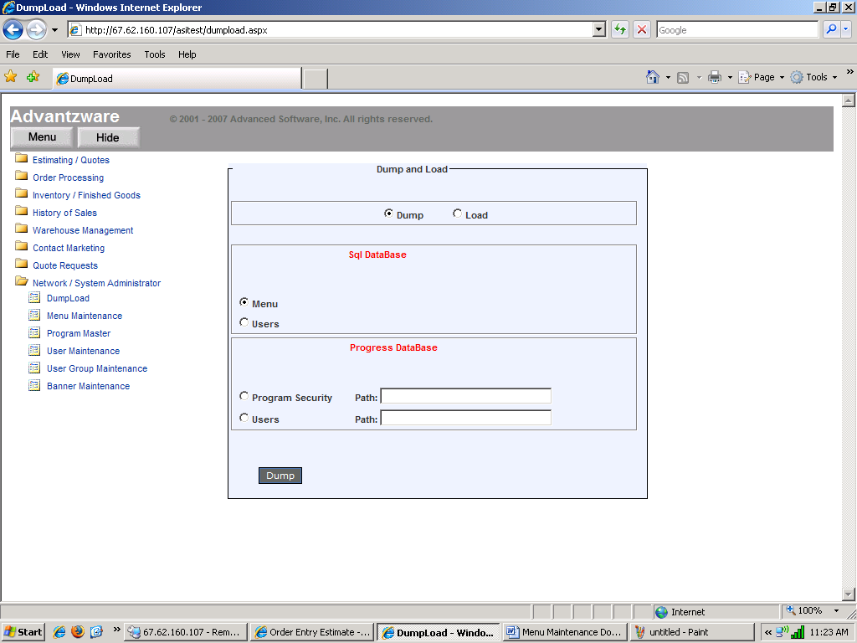

To Dump a Menu Item, Select Menu and then Dump it on required path.

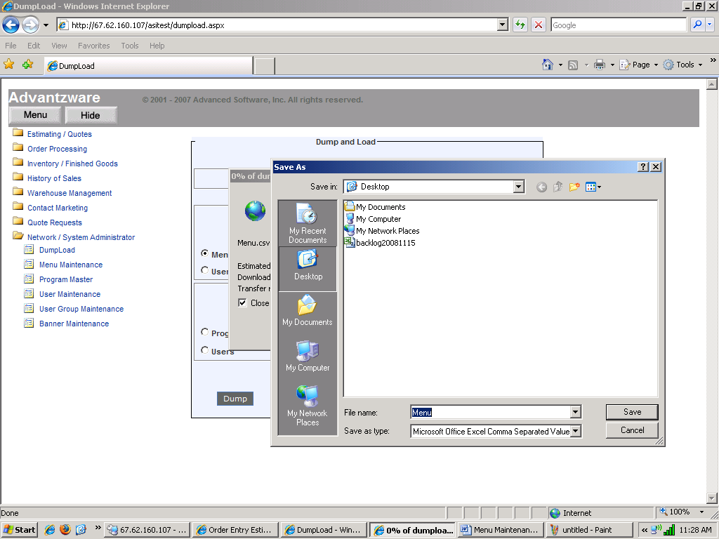

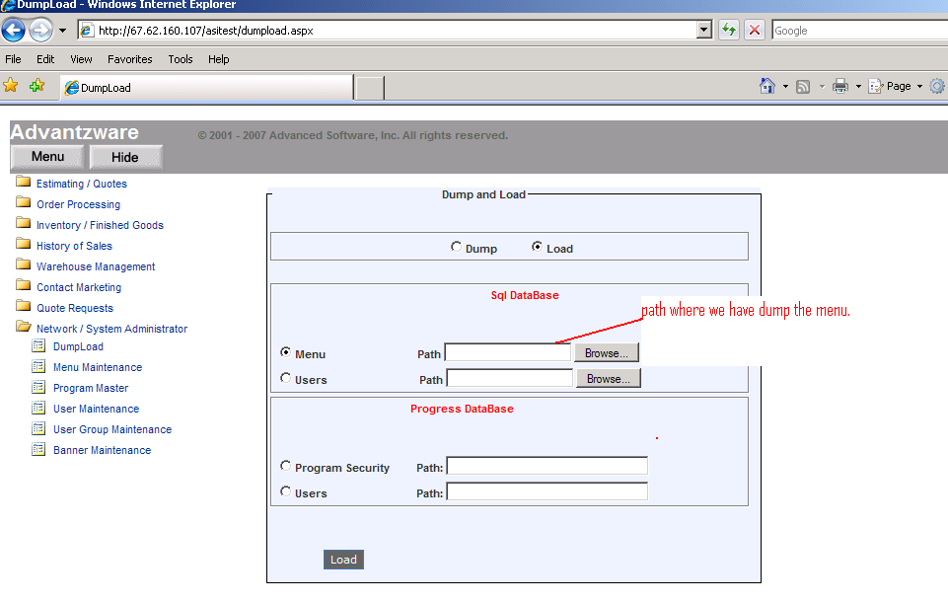

To Load the Menu by giving the location where we dump File.

